FSM Assignment 2 Guide OOP

In order for the simulator to work, the .fsm must follow the following format or else it will result in errors and won’t work.

The format of the .fsm file:

**FSM ----------(name)**

**VAR ----, -------** (If there is more than one variable, the comma must be next to the former like a, b not a,b or a , b)

**States:** (the states names must always start with a and continue alphabetically like a,b,c,d-----)

**a: out “hi bye”**

* if there are more than one action, the comma must be next to the former like

(out X, out Y, wait) not out X , out Y , wait

* There must always be a space between the command and the expression or value. (sleep 10 not sleep10 or out X not outx)
* Each state must end with an end or wait

**Transitions:**

**a, b, 1** (the comma must be connected to the former and the state names must be the same as above states)

* **The FSM always starts at state a**
* **Any equation must be written without any space like (x=x+1 not x = x+1)**

In order to run the simulator, there are two ways :

1. Drag and drop the .fsm file into the .exe file and the FSM will execute
2. Have the .exe and .fsm in the same folder and open the .exe file and write the fsm name and it will execute.

Sample FSM in my folder:

* fsmOne:

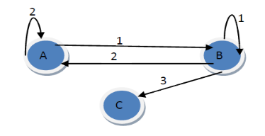

* fsmTwo:

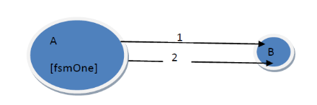

* fsmThree:

1

2 1

1

3

2 0

4 1

* fsmFour:

1

2

2 3

0

4

FSM Simulator Classes Diagram:

In order to compile the code, you must include all header files in the project and the compile and run the source.cpp file that is included in the folder.